# Ideation Phase

**Brainstorm & Idea Prioritization Template**

|  |  |
| --- | --- |
| Date | 15-11-2022 |
| Team ID | PNT2022TMID38117 |
| Project Name | Project - Retail Store Stock Inventory Analytics |
| Maximum Marks | 4 Marks |

## Brainstorm & Idea Prioritization Template:

Brainstorming provides a free and open environment that encourages everyone within a team to participate in the creative thinking process that leads to problem solving. Prioritizing volume over value, out-of-the-box ideas are welcome and built upon, and all participants are encouraged to collaborate, helping each other develop a rich amount of creative solutions.

## Step-1: Team Gathering, Collaboration and Select the Problem Statement

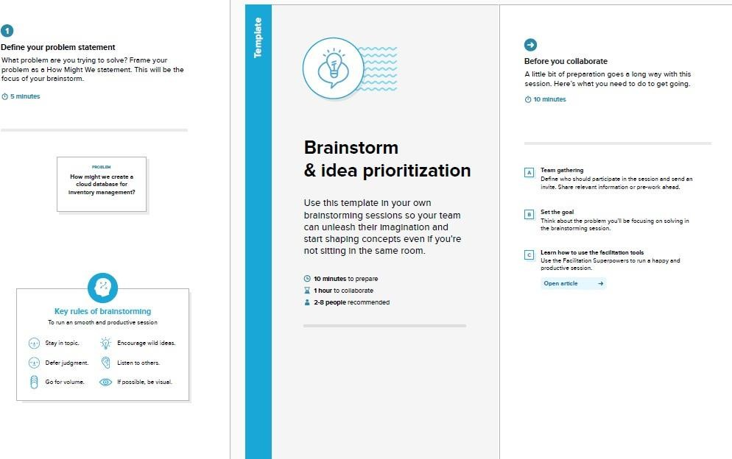

### Step-2: Brainstorm, Idea Listing and Grouping

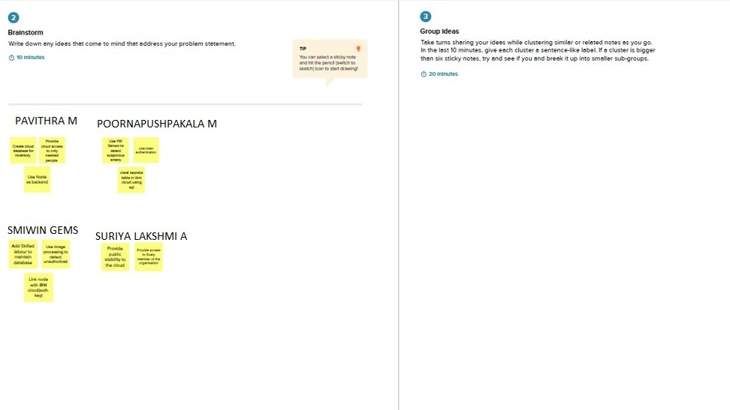

**PAVITHRA M :**

* Create cloud database for inventory.
* Use Node as backand.
* Provide cloud access to only needed people.

### POORNAPUSHPAKALA M :

* Use PIR Sensor to detect suspicious entery.
* Use token authentication.
* create seprate table in ibm cloud using sql.

### SMIWIN GEMS :

* Add Skilled labour to maintain database.
* Use image processing to detect unauthorized.
* Link node with IBM cloud(auth. Key).

### SURIYA LAKSHMI A :

* Provide public visibility to the cloud.
* Provide access to Every member of the organisation.

### Step-3: Idea Prioritization

